Technology Bucket – Smart Vehicles

Category – Software

Problem statement – Warning System for Driver

Organization – ARAI

Team Name – Team Tesseract

Team Leader name – RK Rahul

**Problem Statement**

In order to ensure pedestrian safety and vehicle speed limits in areas with high pedestrian density/residential areas, a system to detect the traffic density/ school areas/ residential areas and accordingly warn the driver about the speed limit for vehicles. The participating teams may use vision based systems which sense the speed limit signs or sign boards for schools/hospitals/accident prone areas etc. and may decide upon the safe speed value with which the vehicle need to operate. The system needs to provide a warning to the driver, if the speed limits are breached. For the purpose of demonstration, the warning may be provided using an LCD or a seven segment simple display and a buzzer. The sign boards for the purpose of demonstration needs to be made according to IRC standards and the same can be used by the system for demonstration purposes.

**Idea Description**

The main objective of the project is to ensure pedestrian safety and monitoring the vehicle speed in highways and accident-prone areas. Over 1.25 million road traffic deaths occur globally every year and majority of the accidents happen due to loss of concentration and violation of traffic rules – Over-speeding, drunk-and-drive. Accident rates can be reduced by a great extent if the drivers are warned beforehand in case of any violations. Machine Learning and Computer Vision techniques are used to train a Convolutional Neural Network for detecting and recognising various traffic signs such as speed limit signs or sign boards for schools/hospitals/accident prone areas, etc. using the Mapilarry traffic sign dataset. A video camera will be fixed on the car which constantly monitors the path of the car. The system will analyse each frame of the video to identify and classify the traffic signs among one of the classes defined in the traffic sign model. Optical Character Recognition (OCR) can be used to compare the values such as speed limit from the recognised image of the traffic sign with real-time speed of the vehicle. If the real-time speed of the vehicle is greater than the maximum speed limit specified in the traffic sign, then it implies that the driver is not violating the traffic rules. Hence a warning would be given to the driver using LCD or a seven segment display and a buzzer. Additionally, it is important to monitor the driver for drowsiness as it might lead to loss of concentration on the road. Haar-cascade classifier and PyGaze can be used to track the blink rate and eye position of the driver. If the driver’s eyes are found to be closed for more than 5-8 seconds, then it can be concluded that the driver is feeling drowsy and a warning will be given accordingly.

**Solution Steps**

1. Train a Convolutional Neural Network to classify traffic signs using the Mapillary dataset.
2. Detect the traffic signs from the live video feed and classify it using the trained model.
3. Obtain the image of the detected traffic sign and apply image processing techniques such as gray scaling and binarization.
4. Apply Optical Character Recognition to detect the speed limit from the detected image.
5. Check the speed of the car with the speed limit value detected from the traffic sign.
6. Eye position and blink rate of the driver is monitored in real time to detect the drowsiness of the driver.
7. Warning is given to the driver in the form of a buzzer of a seven segment display.

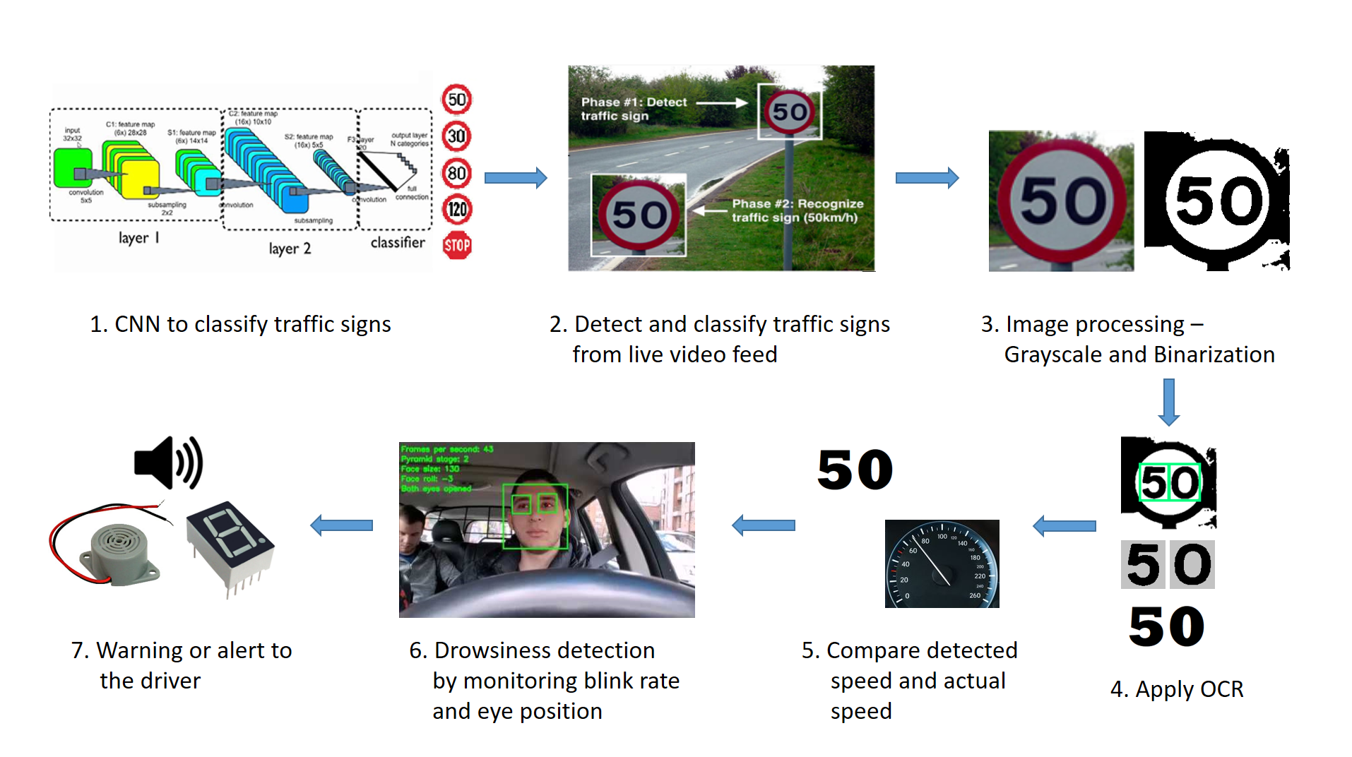

**Value Proposition**

1. Accurate detection and recognition of traffic signs from live video feed.
2. Helps avoid road accidents due to violation of speed and potentially save lives.
3. Detects drowsiness of the driver in real-time.
4. Provides timely warning using a buzzer or seven segment display.
5. Works without internet connection.

**Differentiation**

1. Accurate real-time detection of traffic signs using state-of-the-art YOLO model.
2. Drowsiness detection using the driver’s blink rate and eye tracking.
3. Fast and responsive algorithm.
4. No need for an internet connection and is fully functional when installed.

**Core Technology**

* **Python -** The project is implemented using Python programming language.
* **OpenCV** - It is an image processing library in C++, Python.
* **Convolutional Neural Network (CNN)** - It is a class of deep neural networks, most commonly applied to analyzing visual imagery.
* **YOLO -** You Only Look Once is a state-of-the-art, real-time object detection system. It is trained for detecting traffic signs.
* **Mapillary dataset -** Dataset consisting of traffic signs.
* **Canny algorithm** - Image processing algorithm used for edge detection.
* **Binarization -** It is the process of converting a pixel image to a binary image.
* **Tesseract OCR** - It is an open source ocr engine which can recognize and extract text from images.
* **GazeTracking -** It is a python library used for tracking eye position and calculate blink rate from live video feed.

**Team details**

|  |  |  |  |  |
| --- | --- | --- | --- | --- |
|  | **Name** | **Gender** | **Email id** | **Mobile number** |
| Team leader | Rahul RK | Male | rahulrk.2303@gmail.com | 8778109200 |
| Team member | Shantha Kumar | Male | shantha2106@gmail.com | 9080853461 |
| Team member | Sairamnath K | Male | ksairamnath@gmail.com | 8939551460 |
| Team member | Mohammed Thowfiq S | Male | mohammedthowfiq2@gmail.com | 7010744945 |
| Team member | Vykunth Rao | Male | stingrose@gmail.com | 8939030712 |
| Team member | Navya Reddy V M | Female | venati.navya@gmail.com | 9600076246 |

**Team Skillset**

* **RK Rahul**
  + Quick learner, Adaptive, Motivated, Leadership and Decision making
  + **Projects & Prizes :**
    - Digitization of tabular data from scanned documents
    - Analysis of performance on Online Quizzes using Image processing and Machine learning
    - Paper presentation on Licence Plate Recognition
    - Assistive tool for visually challenged people
    - American Sign Language Recognition
    - Self-driving car simulation using Artificial Intelligence and Convolutional Neural Networks
    - Automatic extraction of Pan-card and License details from scanned documents
    - Secured 2nd place in Ethical hacking hackathon conducted by HackUp technology.
  + **Technical Skills :**
    - Image processing
    - Machine learning & Deep learning algorithms
* **Shantha Kumar**
  + Problem solving, Flexibility, Hardworking, Presentation skills
  + **Projects & Prizes :**
    - Real-time Vehicle Detection and Tracking using Machine Learning and HOG algorithm.
    - Undergraduate research assistant at solarillion foundation machine learning team.
    - Analysing of cinema data using machine learning and shell scripts.
    - Website development and maintenance for Forese club.
  + **Technical Skills** **:**
    - Machine Learning
    - Image processing
* **Sairamnath K**
  + Critical and Creative thinking, Analytical skills, Management skills
  + **Projects & Prizes :**
    - Real-time Vehicle Detection and Tracking using Machine Learning and HOG algorithm.
    - Secured 2nd place in Ethical hacking hackathon conducted by HackUp technology.
  + **Technical Skills :**
    - Data analytics and Data science
    - Image processing
* **Mohammed Thowfiq S**
  + Innovative, Time management, Commitment and Self-management
  + **Projects & Prizes :** 
    - Secured 1st place in Ethical Hacking hackathon conducted by HackUp Technology.
    - Face Detection and Recognition for Security and Surveillance Systems using Artificial Intelligence and Computer Vision.
    - Object Detection and Classification using Deep Learning.
    - Fake News Analysis using Natural Language Processing.
    - Developed an android app for online shopping.
    - Developed an android app for booking parking spots.
  + **Technical Skills :**
    - Machine Learning and Deep Learning algorithms
    - App development
    - Database management
* **Vykunth Rao**
  + Teamwork and Collaboration, Logical Reasoning and Determined
  + **Projects & Prizes :**
    - Movie recommendation engine using Artificial Intelligence.
    - Website for D.G Vaishnav college using HTML / CSS / Javascript / MySQL
    - Paper presentation on Licence Plate Recognition
    - Secured 2nd place in Ethical hacking hackathon conducted by HackUp technology.
    - Undergraduate Research assistant at Solarillion foundation's machine learning stream
  + **Technical Skills :**
    - Machine learning
    - Web development
* **Navya Reddy V M**
  + Communication skills, Professionalism, Reliable and Dependable
  + **Projects & Prizes :**
    - Voice Assistant using Artificial Intelligence and Natural Language Processing.
    - Audio book for visually challenged
  + **Technical Skills :**
    - Machine learning
    - Software development
    - Documentation and Modelling